SENIOR SAFETY CONSULTANT LLC. |  | 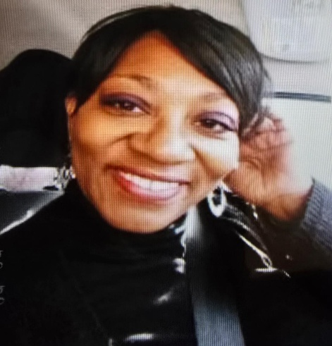
QUARTERLY  NEWSBLOG | ISSUE #1
Date  BLACK FARMERS ARE STRONGER TOGETHER!  DEAR Black Farmer(s)  Welcome to Our Black Farmers Community Blog.  I am writing to express my interest in sharing food for thought that uplifts, informs, and empowers our farming community as we continue building strength, sustainability, and justice in agriculture.  Our Mission:  To uplift Black Farmers.  BLACK FARMERS IN AMERICA  Black farmers have played a critical but often overlooked role in shaping food access and addressing food disparities in the United States -even while facing systemic discrimination that severely reduced their numbers and land ownership. Their contributions are best understood in three interconnected ways.  Feeding Local Communities, Especially in the South  Historically, Black Farmers Supplied:  Fresh vegetables, meat, and grains to rural Black communities.  Local markets, churches, schools, and mutual aid networks.  - Rebuilding Alternative Food Systems During Segregation.  Cooperative Farms  Mutual aid Food networks  Informal Produce Exchanges  - These systems reduced hunger and stabilized food access during Jim Crow-Functioning as early models of community-based food security.  The loss of the Black Farmland wasn’t accidental. It resulted from:  ∙USDA LOAN DISCRIMINATION | 25 January 2026
 | 25 January 2026 | Contact
 | 25 January 2026 |  | 1840 Pyramid Pl, Memphis, TN 38132
 | 25 January 2026 |  | (901) 779-4788
 | 25 January 2026 |  | Theworkemail25@yahoo.com
 | 25 January 2026 |  | The Writer: Claudette J Jackson
∙HEIR PROPERTY LOSS
∙VIOLENCE, INTIMIDATION, AND LAND THEFT
∙EXCLUSION FROM FEDERAL FARM PROGRAMS

THIS ALL LED TO:

- LESS LOCAL FOOD PRODUCTION IN BLACK COMMUNITY.
- GREATER DEPENDENCE ON DISTANT, CORPORATE FOOD SYSTEMS.
- HIGHER FOOD PRICES AND POORER NUTRITIONAL OPTIONS IN HISTORICALLY BLACK REGIONS.

CLOSING STATEMENT:

“My grandfather, Henrey Burrows like many other Black farmers, helped build early food security systems for marginalized communities. Under segregation, they created independent food networks when mainstream systems excluded them. When Black farmers loss farm land and or were forced off from working on their own farmland; collapse our food systems gave rise to production and produce suppressions. Those same communities later became food deserts- and today, their legacy stands at the center of food justice and food equity movements.

The farmland was our survival we could depend on it. USDA Farm Loan(s) suppression created real systemic issues and long-term devastating effects for us as Black farmers and heirs. Although, Black farmers had limited education; yet the hands of their free labor produced (economic warfare) billions and trillions of dollars of wealth in the USA of America. Sadly, this is how discrimination against Black farmers increased food disparities.

USDA DEACTIVATED Black Farmers; “There is documented history and legal findings showing there the U.S. Department of Agriculture (USDA) engaged in discriminatory practices that effectively prevented many black farmers from receiving fair access to farmland loan, operation loans, disaster relief, and housing loans. See Pigford v. Glickman

Denied operating and ownership loans
Delayed until planting seasons passed
Given smaller loans then white farmers
Pushed into foreclosure through denial of restructuring
Excluded from disaster and emergency relief.

How do we get together and legally fight back? How do we invite Heven into this earthly issue? How do we get into alignment? Let me answer in three layers: Legal action, Spiritual Alignment, and Collective Power.

We can expect positive change when people of color (Black farmers) move organized, documented, and unified – not scattered, not isolation. Justice is spiritual work. Scripture says” “Let justice roll down like waters, and righteousness like a mighty stream.” Amos 5:24
Heaven doesn’t move through chaos-it moves through alignment.

 Mr. Thomas Burrell, President of (BFAA) Black Farmers Agriculture Association; The “True Advocate” of the People of Color In Farming
At Black Farmers and Agriculturalists Association (BFAA), support Black Farmers in fighting discrimination through the legal system and fight for justice we deserve as “Black Farmers,” Heir’s. If you want to join the cause for a better future for Black farmers and agriculturalists. For mor information please call 901-522-8880 or sign up at www.bfaainc.com

I just wanted to encourage you to take a stand and activate your voice and fight a more Human Right. For more information, please contact SSCC Senior Safety Consultant Center LLC, for more information.

